**Experiment 1:-**

Design a LED Flasher.

**Circuit Diagram:-**

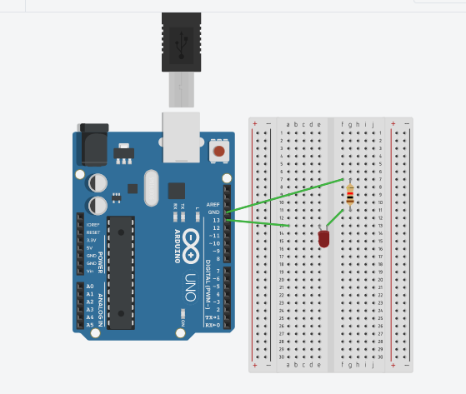

**Theory:-**

**Concept used:-**

The concepts used in this experiment are:-

* The arduino board can supply a power of 5v as digital output signals through the 14 pins (namely 0-13) present in it as digital input or output pins.
* The GND pin of the arduino board acts as ground.
* In the bread board, the two rows present at the top and bottom each, are connected with each other in series combination and the columns present in between are connected in a set of 5 each. The connection pattern is shown below: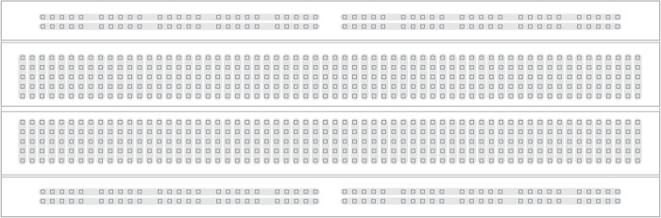

**Learnings and Observations:-**

**Learnings:**

* I have learned how to make a series circuit using an arduino board and a breadboard.
* I have learned how an arduino works and also learned how current flows and how it works.
* I have gained a practical experience of how an LED and a resistor work.

**Observations:-**

* When we pass electrical signals to the arduino through our code the LED glows and gets off accordingly.

**Problems and Troubleshooting:-**

The problems faced while doing this task are :-

* The Arduino board was not working properly.
* Connections were not tight.
* The LED was fused. I had to replace it.

**Precautions:-**

The precautions that we need to remember while doing this experiment are:-

* The connections at different points should not be loose
* Wires should be connected properly.
* The two pins of the LED should be connected at their correct point that is the positive terminal should be connected with the p pin and the negative terminal should be connected with the n pin.

**Learning Outcomes:-**

* I have learned how to make circuits using an arduino board and a bread board.
* Through this experiment, I have gained the skill of controlling the functions done by the circuit with the help of codes.